**Wellbeing Challenge**

Choose your level and spell your name. Want to make it harder, add in middle and surnames. Why not challenge the rest of your family to join you. Clear a space, get some music on and do a workout together.

Afterwards all take the time out of your day to try the five minute relaxation activity. This is as important for us all with busy lives as exercise. Again, put some quiet relaxing music on, or alternatively go for silence and concentrate on the noises you can hear all around you.

For younger brothers and sisters:

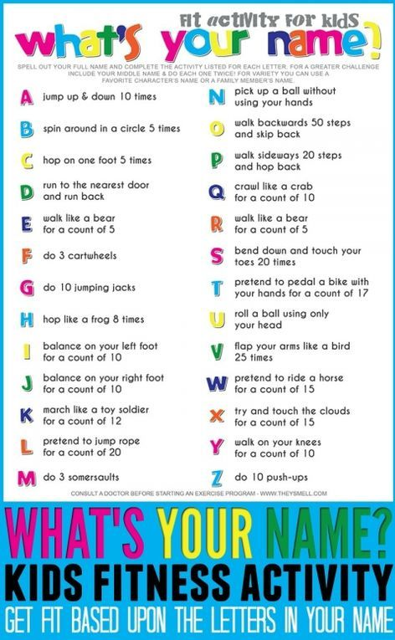

For those feeling brave:

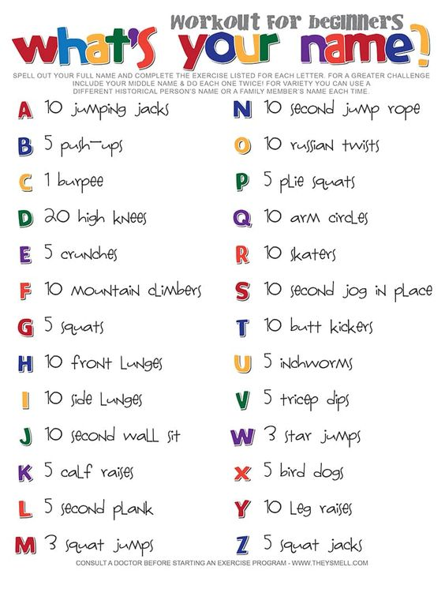

For a little extra spice…: 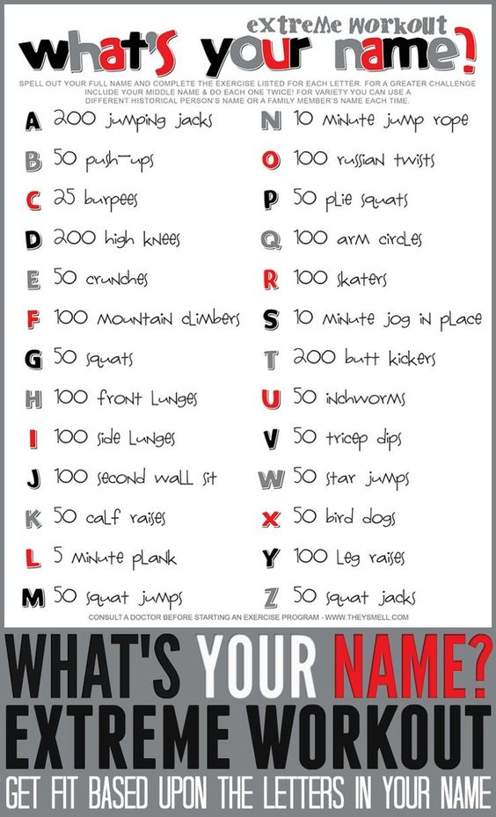

Time for some relaxation, please take the time to try this!