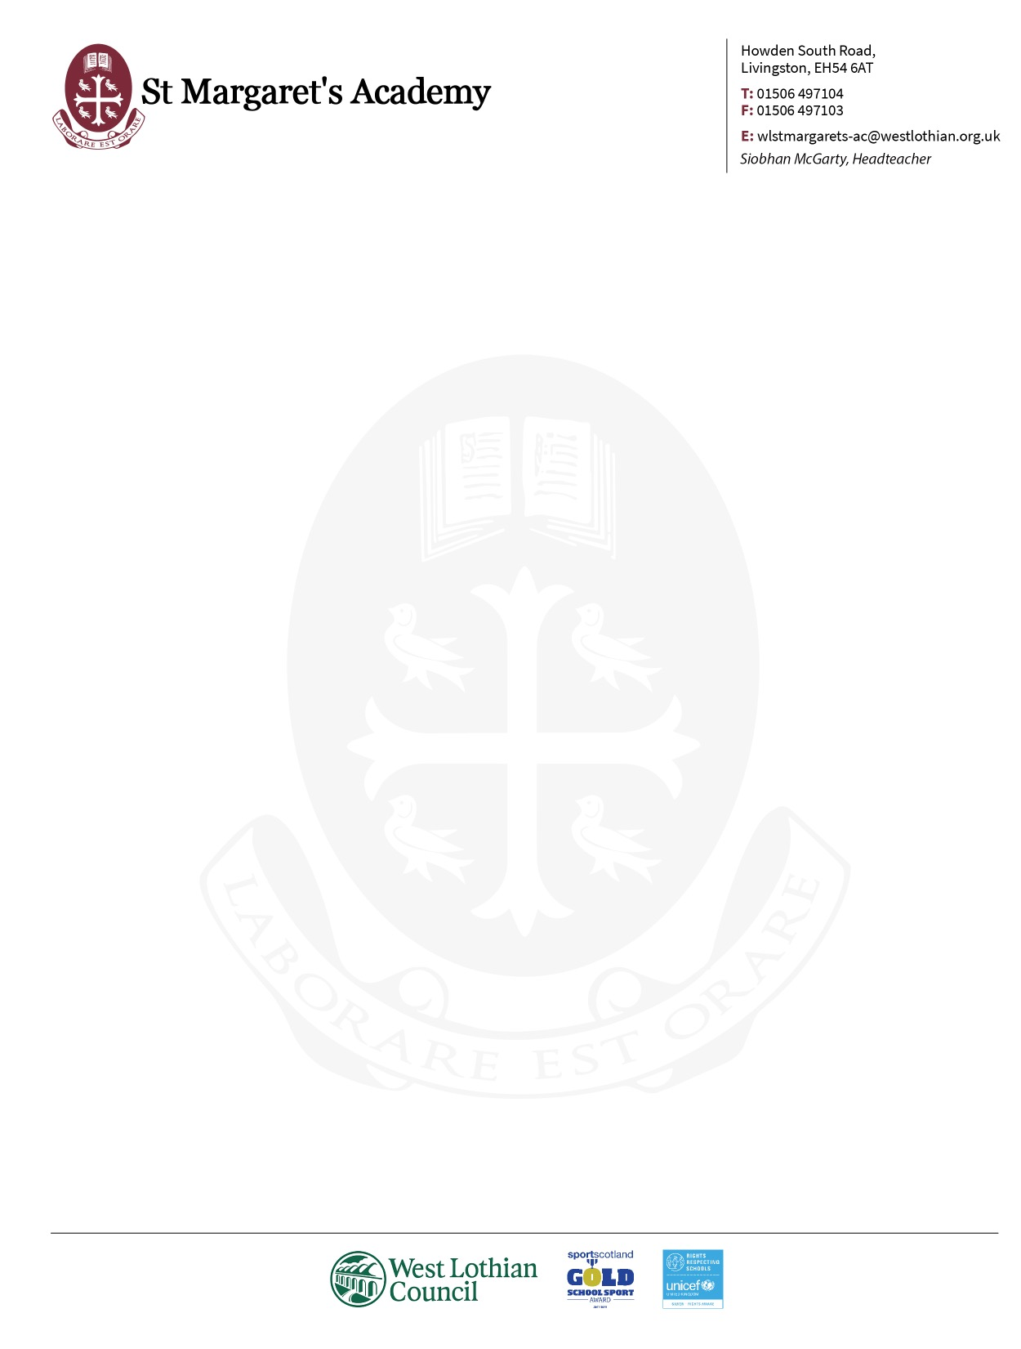

Dear Parents and Carers

I hope that you and your families are keeping safe and well.

We are holding year group assemblies this week and it has been great to speak to our young people directly. It is important that our students keep up their studies at this time but we understand that it is a challenge to do so. Our teachers are working with pupils to engage them in activities that will continue to build their learning and support them in progressing to the next stage.

Our S1-S3 groups are settling into their blocks of learning, and we are now preparing for our senior pupils in S4-S6 to begin their new coursework. Our team are working together to do this by developing online approaches to study that are flexible, taking in to account the well- being of our students and family life during our current situation.

Our senior pupils are working with their teachers to consolidate their learning and build on skills needed for the next stage. We have also started Religious Beliefs and Values with S4 which is a level 6 (equivalent to Higher) award. Also a number of courses for example, Leadership, are in the S5 and S6 Teams online.

Our plan is that all pupils will ‘move up a year group’ on the week starting the 4th May and will access new Microsoft Teams from this point.

Subject areas will invite new S4-S6 pupils to join Microsoft Teams groups for each of their subject choices which were completed by pupils in March. If for any reason your child has not completed their course choice form, please contact your Head of House who will support you with this.

To maximise success at a range of levels, pupils will have the opportunity to change courses and levels in August. Therefore at this stage all course choice invites are provisional and are open to change once we return to school.

Teachers will be spending this week and next online teaching and planning lessons. They will also be setting up new Microsoft Teams in preparation for this move.

We have issued a number of devices for pupils to have access at home. This facility is still available so please let us know via the school email address if your child requires a device. We have also issued a number of paper learning packs which we will refresh and issue new materials for this next stage.

Our Digital Champions Team are here to help with online learning questions, and they will answer if your child sends a message on their year group Team. We are also going to discuss this during assemblies.

I really appreciate your support with your child’s learning and understand that you will be doing this as well as supporting your families in many ways. As a school community, we are strong and support each other. Our Pupil Support team are calling each of their House groups to say hello and ask if you need anything, and we are here to help. You can also contact using the school office email: wlstmargarets-ac@westlothian.org.uk

I will keep you updated on developments in preparing for this next phase of learning.

Best wishes to you and your families.

Mrs McGarty